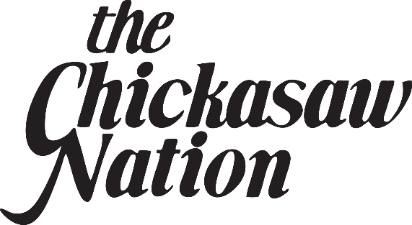
((SUGGESTED LEAD IN))
AN INAUGURATION CEREMONY TODAY MARKED CHICKASAW NATION GOVERNOR BILL ANOATUBBY’S UNPRECEDENTED NINTH TERM.

((TAKE VO
CG: Chickasaw Nation Inauguration
Ada, OK))
THE CEREMONY TOOK PLACE AT EAST CENTRAL UNIVERSITY IN ADA WHERE GOVERNOR ANOATUBBY SAID IT HAS BEEN AN HONOR TO SERVE THE CHICKASAW PEOPLE.

((TAKE SOT
CG: Bill Anoatubby
Governor, Chickasaw Nation
0:18
“We will honor that trust and we will continue to improve. With each new endeavor, change, and challenge, we strive for excellence. Together, with your help, we can continue to build an even brighter future for generations to come.”))

((VO))
FIRST ELECTED AS GOVERNOR IN NINETEEN-EIGHTY-SEVEN, GOVERNOR ANOATUBBY HAS HELPED LEAD THE CHICKASAW NATION TO TREMENDOUS GROWTH IN DIVERSE AND PROSPEROUS BUSINESS OPERATIONS.

((SOT
ANOATUBBY
0:19
“In 1987 we set out to develop a sound economy for the Chickasaw Nation to celebrate our rich heritage and to safeguard our sovereignty. We’ve accomplished many of those goals and found new and exciting ways to continue fulfilling our mission.”))

((VO))
TRIBAL BUSINESSES GENERATE THE REVENUE NEEDED TO OFFER MORE THAN TWO HUNDRED VITAL PROGRAMS AND SERVICES TO CHICKASAW PEOPLE AND CREATE A POSITIVE ECONOMIC IMPACT TO THE STATE.

((ANOATUBBY
0:25
“We continue to have a firm financial foundation as our businesses strive every day to sustain our mission and enhance the lives of our people. And they will continue to generate the revenue needed to grow the services and programs by reaching new markets, developing new business opportunities, and continuing to concentrate on good stewardship of our resources.”))

((SUGGESTED TAG))
OATHS OF OFFICE WERE ALSO TAKEN BY LIEUTENANT GOVERNOR ELECT CHRIS ANOATUBBY, TRIBAL LEGISLATORS DERRICK PRIDDY, LINDA BRIGGS, LISA JOHNSON BILLY, AND BETH ALEXANDER, AND SUPREME COURT JUSTICE MARK COLBERT. THE CEREMONIES WERE HELD AT THE AT-UH-LOW-UH THEATER, NAMED FOR THE CHICKASAW HALL OF FAME MEMBER.

